**Noter App – Assignment**

**Process:**

**Set Up AWS Resources**

Logged in to AWS Management Console.  
• Launched EC2 Instance: (virtual machine - Ubuntu).

And security groups to allowed HTTP (port 80) and SSH (port 22) traffic with instance type - T2.medium and 15Gb disk size and created PPK file.

**Connect to Your EC2 Instance**

•    Used SSH to connect to EC2 instance using the PPK file via Putty as below.

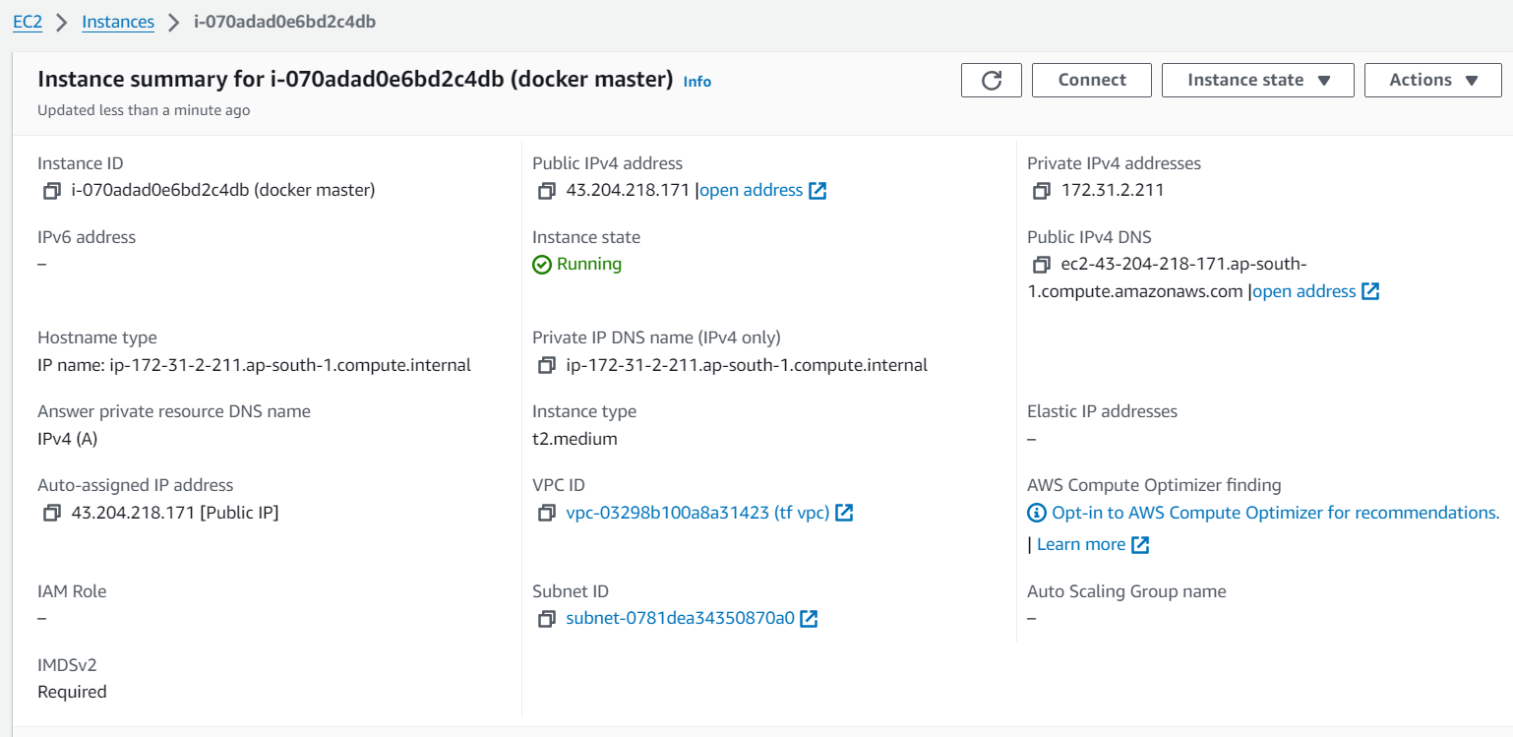

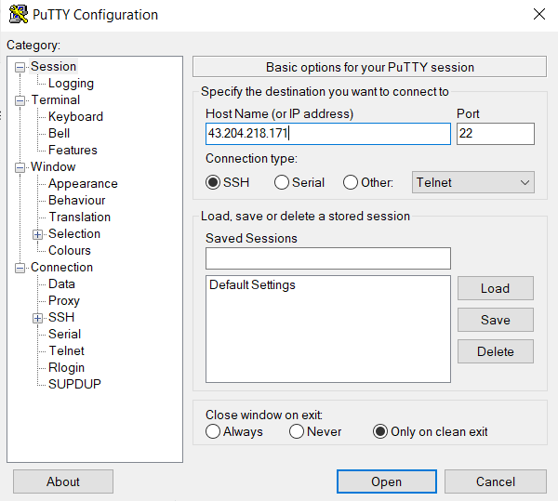

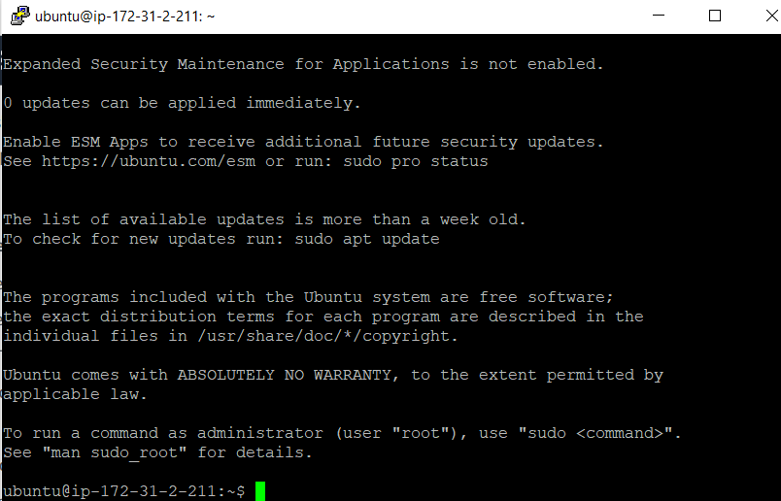

**Attached IAM Role to the machine :**

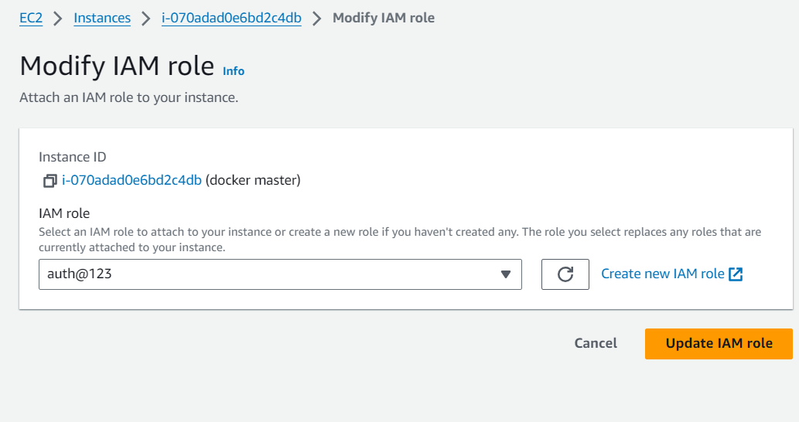

**Creation of docker file :**

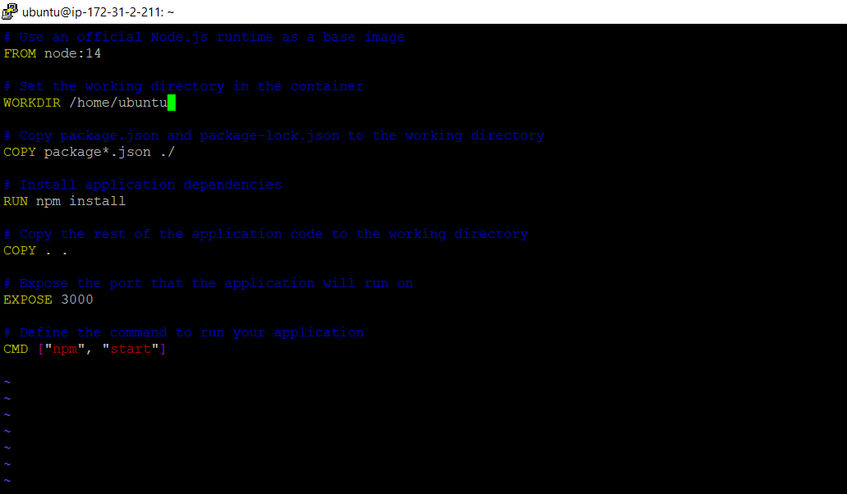

**Docker File :**

# Use an official Node.js runtime as a base image

FROM node:14

# Set the working directory in the container

WORKDIR /home/ubuntu

# Copy package.json and package-lock.json to the working directory

COPY package*.json ./

# Install application dependencies

RUN npm install

# Copy the rest of the application code to the working directory

COPY . .

# Expose the port that the application will run on

EXPOSE 3000

# Define the command to run your application

CMD ["npm", "start"]

**Uploaded NOTER App code on to the own github account from local machine and clone it to remote as machine as below:**

**Github repo :** [**https://github.com/coolbudadi/nodejs-application.git**](https://github.com/coolbudadi/nodejs-application.git)

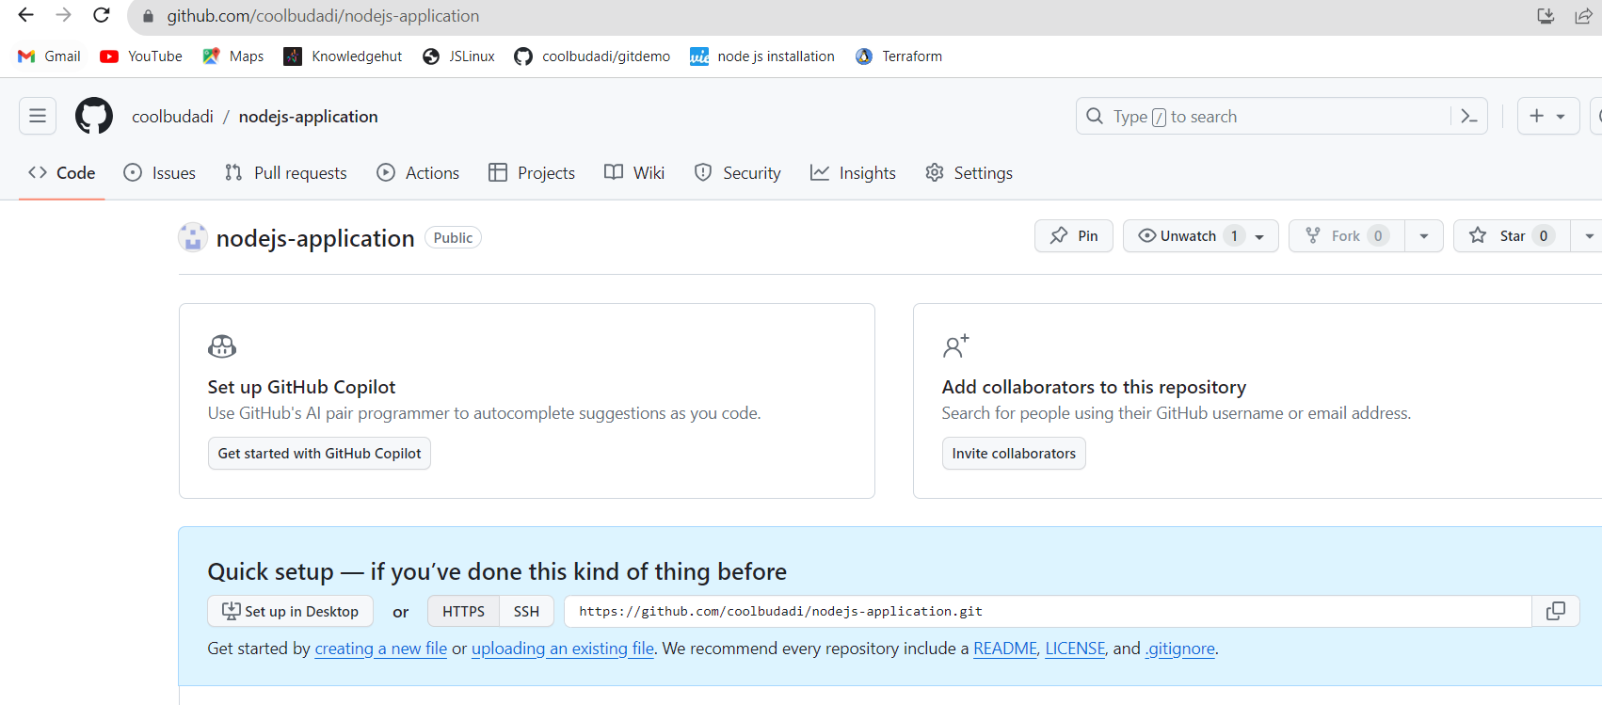

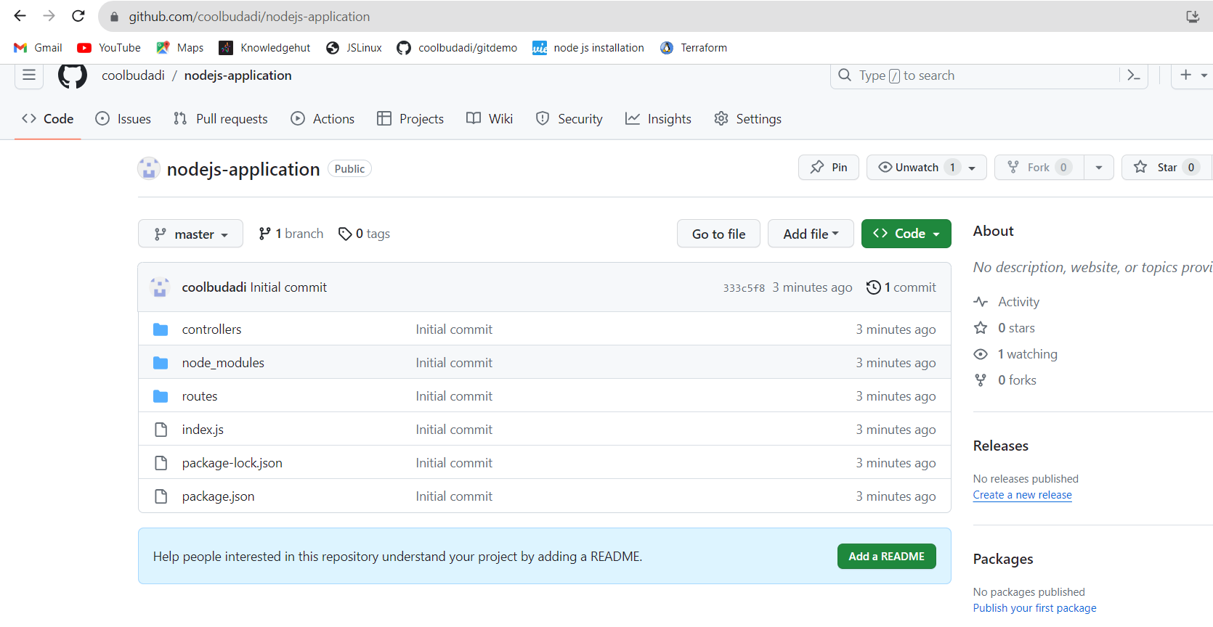

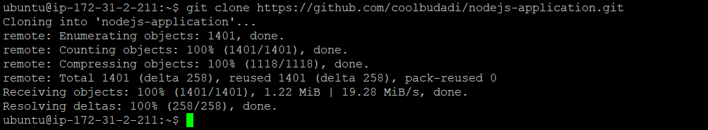

**Listing out the code and change directory to the application code as below:**

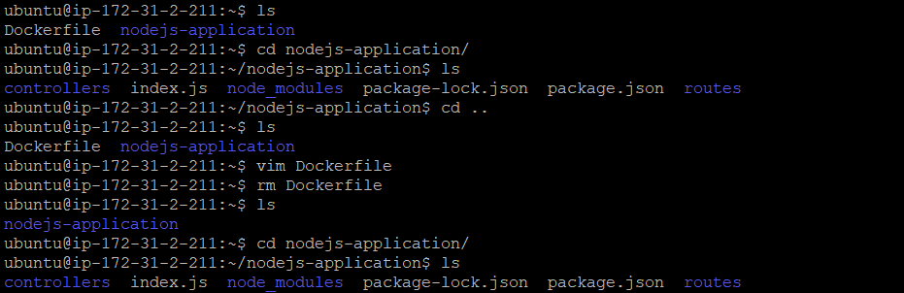

**Installed Docker on to the machine as below:**

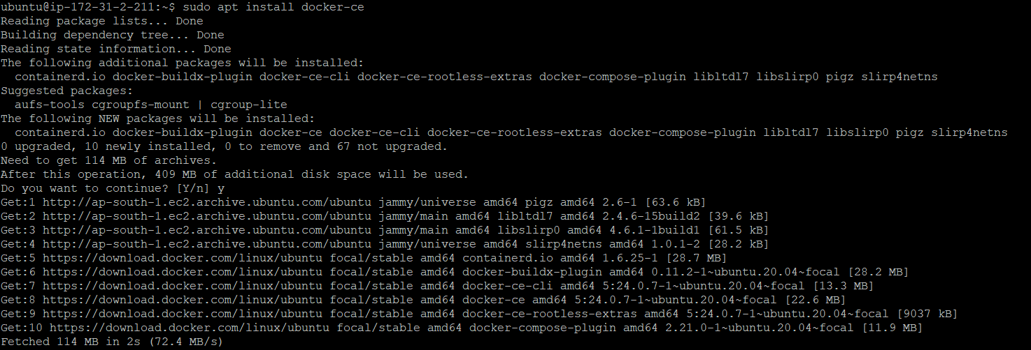

**And built a code a using docker build for converting code to machine readable.**

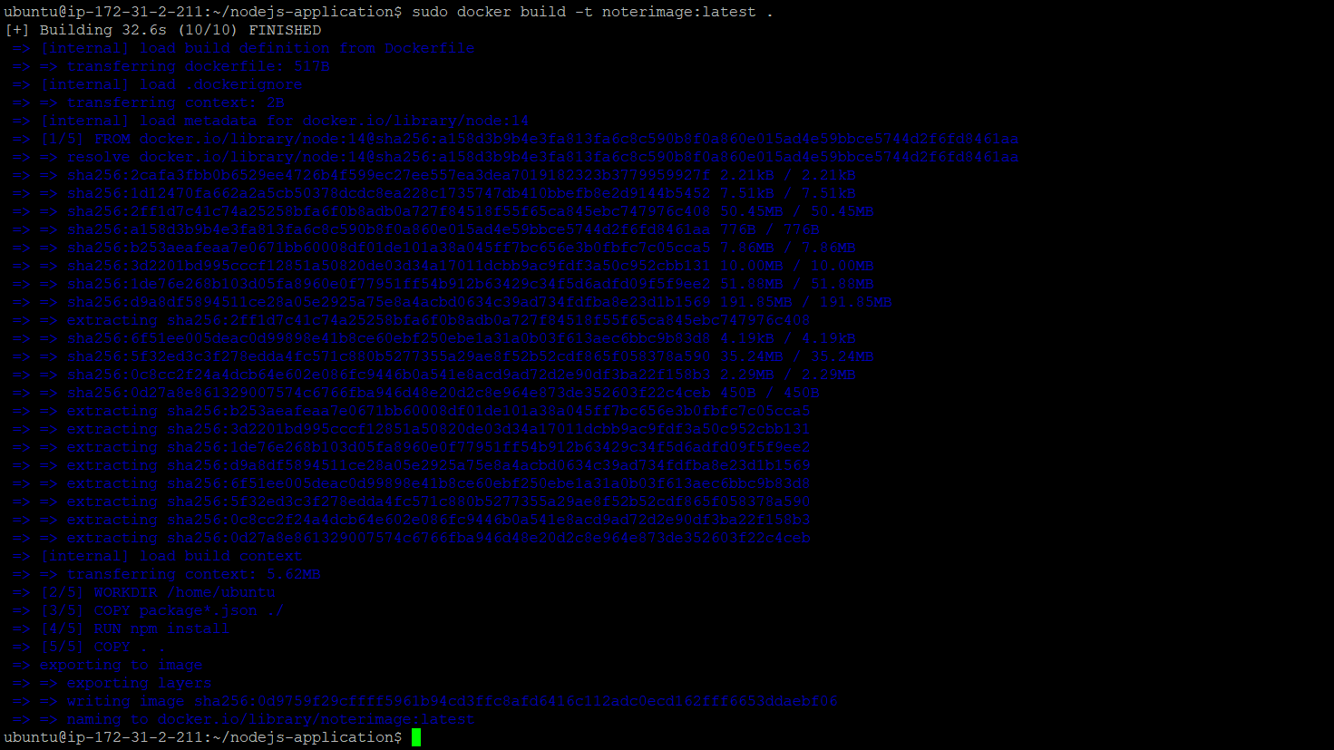

**After built up docker file will get the docker image as below:**

* **docker images**



**Now uploading/pushing the image to dockerhub :**

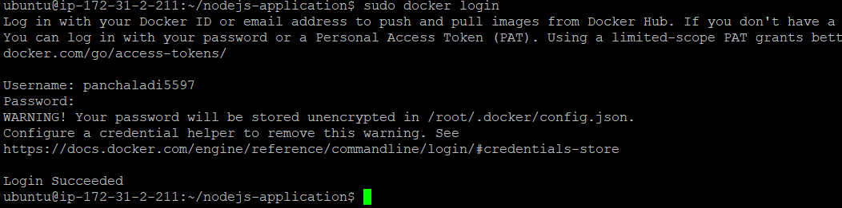

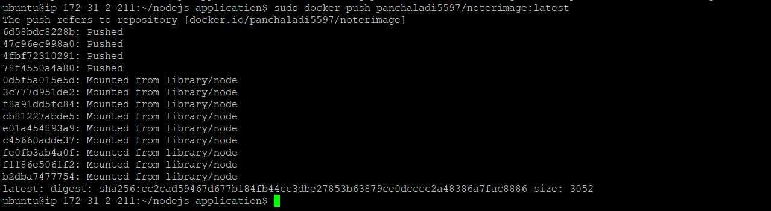

**Uploaded Docker images :**

Docker hub :<https://hub.docker.com/repository/docker/panchaladi5597/noterimage/tags?page=1&ordering=last_updated>

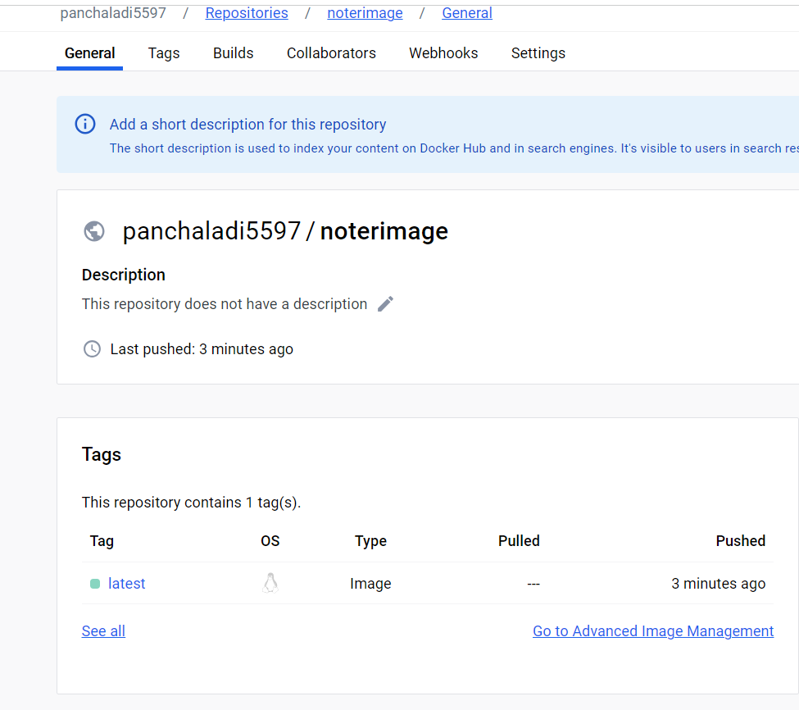

**Created a new image and built which is going to be the version 2 of the Noter application as below:**

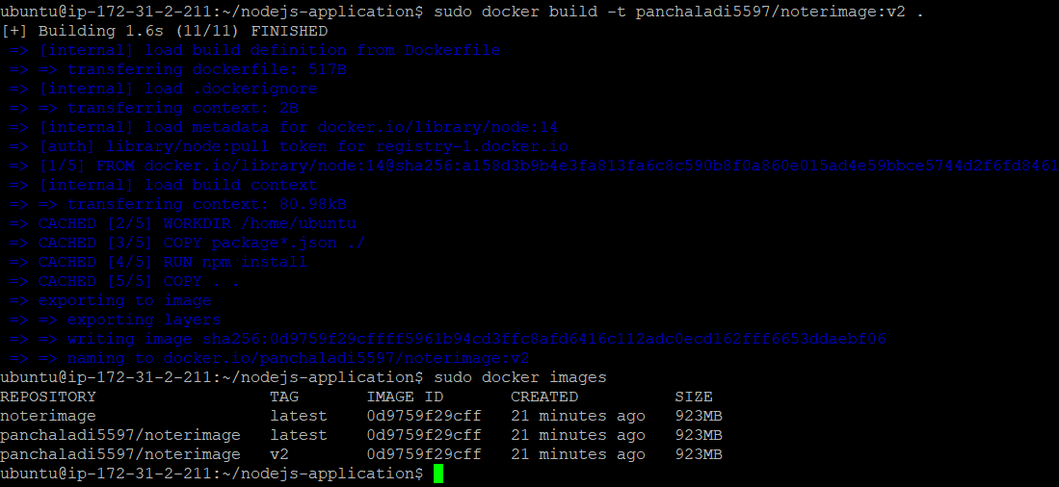

**Docker-compose file for running multiple containers or image as we can see below is the docker compose file:**

version: '3'

services:

noter-v1:

image: panchaladi5597/noterimage:latest

ports:

- "5000:3000"

environment:

- NODE_ENV=production

noter-v2:

image: panchaladi5597/noterimage:v2

ports:

- "5000:3000"

environment:

- NODE_ENV=production

**Added a port entry to SG :**

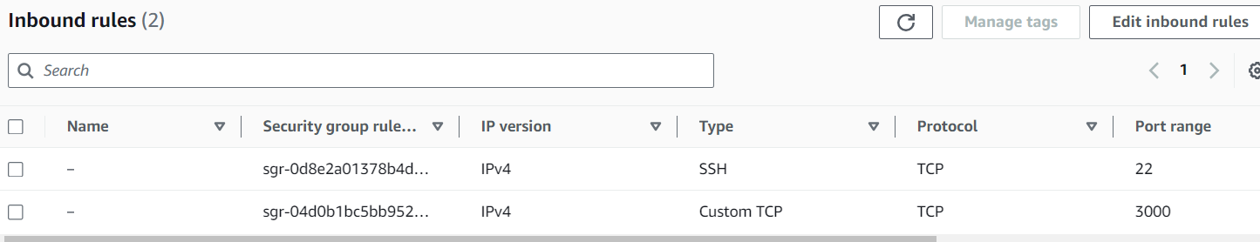

**Installed Docker-compose on to the machine as below:**

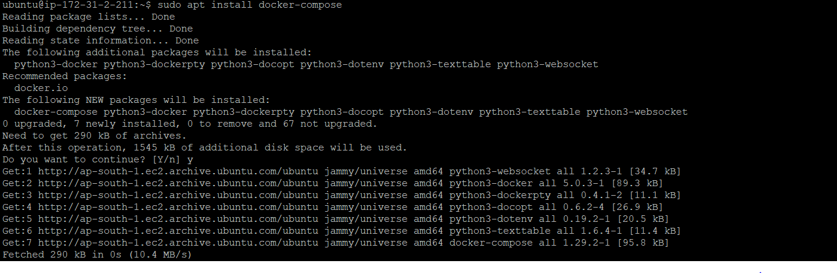

**Again pushed updated two images on to the docker hub as below:**

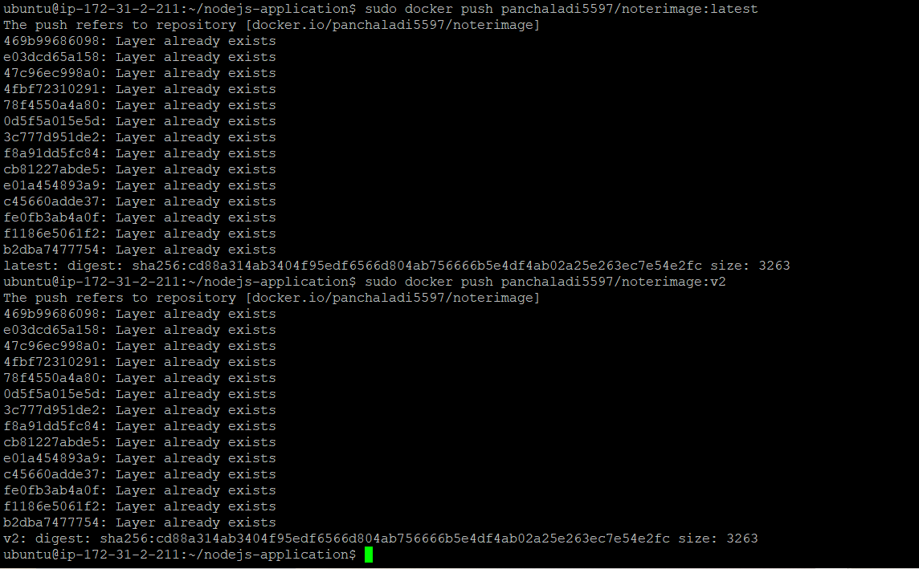

* **Running docker compose  file**

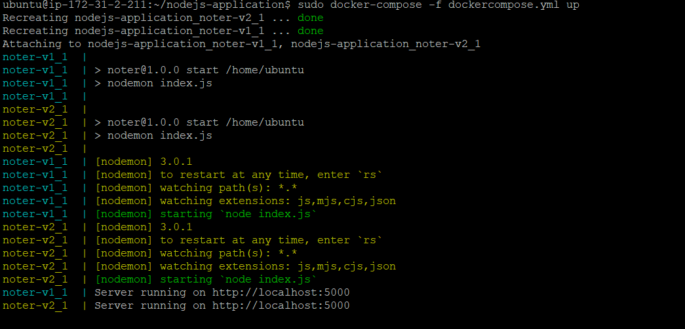

**And we got successful result our both images are running by using docker compose file .**